# Solution of the Problem4 (Module 3)

## Schema Design and Explanation

### Fact Table

1. Star Schema is used as only five dimensions are there
2. Fact Table name is **SalesRecord**. It maintains the entry for each productService/Merchandise bought
3. Fact Table has the following fields:

* SalesRecordNo (PK)
* SalesQty (as it was in Contains Table)
* SalesUnitPrice (Price of Merchandise, Price of Service, may be ServiceCategory, Special Events, Membership Price from MemberType Table)
* SalesTotalAmt (Keep Track of Total Money Earned)
* isService (Yes or No) (To check entry recorded is of Service or not)
* isMerchandise (Yes or No) (To check Entry recorded is of merchandise or not)

### Dimensions Tables

**Franchise**

* FranchId (primary key)
* FranchRegion
* FranchPostalCode
* FranchModelType

**Member**

* MemId (Primary Key)
* MemName
* MemZip
* MemDate (MembershipDate)
* MemEmail
* MemType (Taken from ERD MemType Table, default values for Guest, Corporate Customer)

**Calendar**

* CallId (primary key)
* CallDay
* CallMonth
* CallYear

**ProductService**

* ProdId (Primary Key)
* ProdName
* ProdType (Special Event, Service, MemberShip)

**Merchandise**

* MerchId (Primary Key)
* MerchName
* MerchType

The statement of entities relationships: *SalesRecord* ***Of*** *ProductService/Merchandise* ***Bought By*** *Member* ***On*** *Calendar Suppiled* ***By*** *Franchise*

### The overall Schema

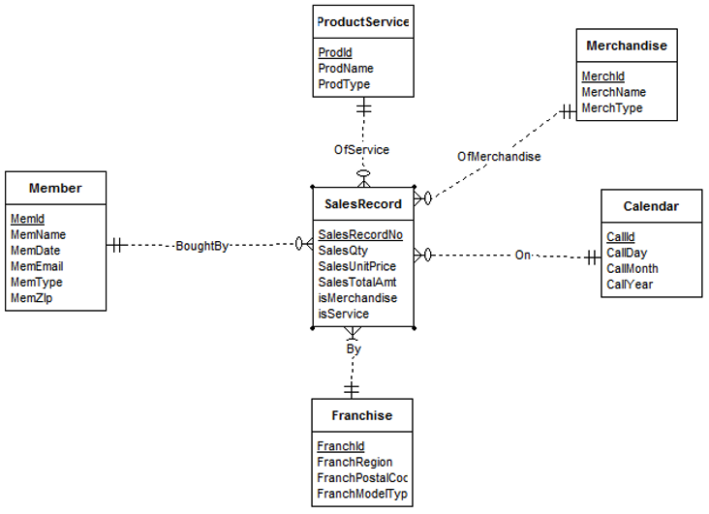

This diagram shows the star schema, with the SalesRecord as the middle and other dimensions have 1 to Many relationships to it.